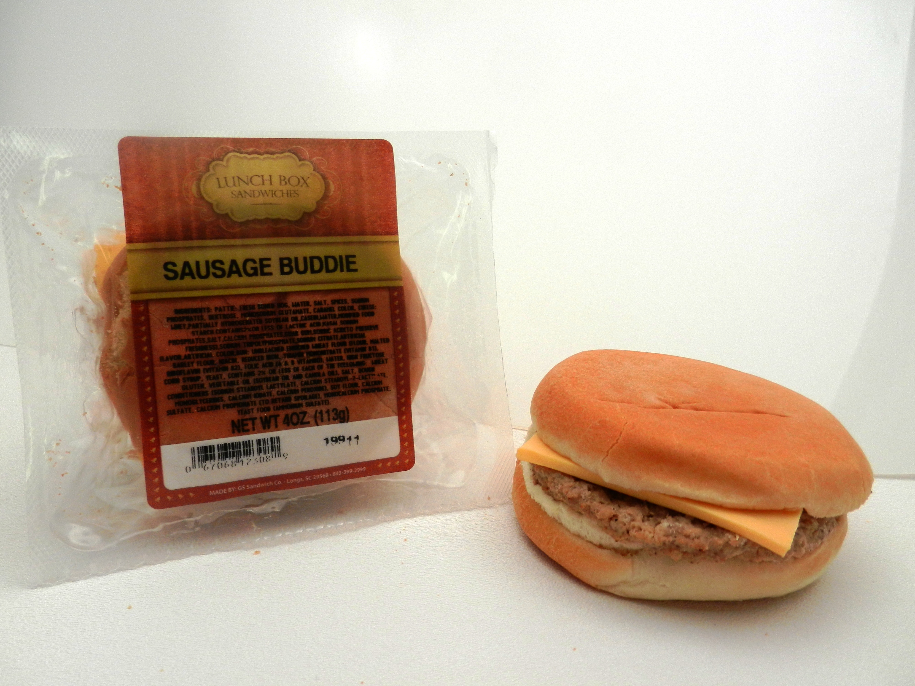
Nutritional Analysis
Item No: 2308
Brand: Lunch Box Sandwiches
Category: Frozen Packaged Sandwich
Description: Sausage Buddy
Pack Size: 5 per Case/ Each Item weigh 4 oz
Shipping Dimensions: 10x6x6
Item Net Weight: 4 oz
Gross Weight: 1.54 lb
TI/HI: 28 per layer x 10 layers high = 280 per pallet
Storage Temperature: Frozen
Shelf Life: 6 months frozen.
UPC: 0 6706892308 9

Ingredients:
INGREDIENTS:
PATTIE: FRESH BONED HOG, WATER, SALT, SPICES, SODIUM PHOSPHATES, DEXTROSE, MONOSODIUM GLUTAMATE, CARAMEL
CHEESE: WHEY, PARTIALLY HYDROGENATED SOYBEAN OIL, CASEIN, WATER, MODIFIED FOOD STARCH, CONTAINS 2% OR LESS OF LACTIC ACID, KASAL, SODIUM PHOSPHATES, SALT, CALCIUM PHOSPHATES, GUAR GUM, SORBIC ACID (TO PRESERVE FRESHNESS), SODIUM TRIPOLYPHOSPHATE, SODIUM CITRATE, ARTIFICIAL FLAVOR, ARTIFICIAL COLOR,
BUN: UNBLEACHED ENRICHED WHEAT FLOUR (FLOUR, MALTED BARLEY FLOUR, NIACIN, REDUCED IRON, THIAMIN MONONITRATE (VITAMIN B1), RIBOFLAVIN (VITAMIN B2), FOLIC ACID (A & B VITAMIN)), WATER, HIGH FRUCTOSE CORN SYRUP, YEAST, CONTAINS 2% OR LESS OF EACH OF THE FOLLOWING: WHEAT GLUTEN, VEGETABLE OIL (SOYBEAN OIL AND CANOLA OIL), SALT, DOUGH CONDITIONERS (SODIUM STEAROYL LACTYLATE, CALCIUM STEAROYL-2-LACTYLATE, MONOGLYCERIDES, CALCIUM IODATE, CALCIUM PEROXIDE), SOY FLOUR, CALCIUM SULFATE, CALCIUM PROPIONATE (TO RETARD SPOILAGE), MONOCALCIUM PHOSPHATE, YEAST FOOD (AMMONIUM SULFATE).

Nutritional Information:
Serving Size 1 sandwich 4 oz
Servings per container 1
-----------------------------------------------------------
Amount per serving
Calories 415 Calories from Fat 221
-----------------------------------------------------------
Daily Value %
Total Fat 24.5g 38%
Saturated Fat 8.5g 43%
Trans Fat 0g 0%
Cholesterol 35mg 12%
Sodium 955mg 40%
Total Carbohydrate 37g 12%
Dietary Fiber 1.0g 4%
Sugar 5.5g
Protein 11.5g
-----------------------------------------------------------
Vitamin A Vitamin C
Calcium 20% Iron 12%

Heating Instructions:
~ For best results thaw product completely before heating.

Microwave: Place wrapped sandwich in the microwave on high heat for 60-90 seconds or until warm.

* Cooking Methods and Temperature may vary.

* Shelf Life – 6 months frozen and 28 days once thawed.
* Storage Requirements – frozen until the end user is ready to thaw product

